A Systemic Framework for Assessing the Risk of Decarbonization to Regional Manufacturing Activities in the European Union

Supplementary Information
Table A1. Indicator metadata and sign conventions for the TRI region–sector panel. The table lists each metric, its pillar, whether it varies by subsector, units, spatial resolution (original vs. used), and sources. Indicators with Sector = No or NUTS0 resolution are applied uniformly across subsectors (and, when NUTS0 persists, uniformly within a country); others vary at NUTS2 by region–sector. “Direction” is the orientation used before normalization: Positive increases vulnerability (e.g., GHG emissions, fossil share, labour slack, unemployment, extra-EU trade), while Negative reduces it (e.g., renewables share, wages, skills, BERD, innovation, capital formation). These choices standardize inputs across exposure and the five vulnerability pillars for aggregation in the TRI.
Table A1: Indicator metadata
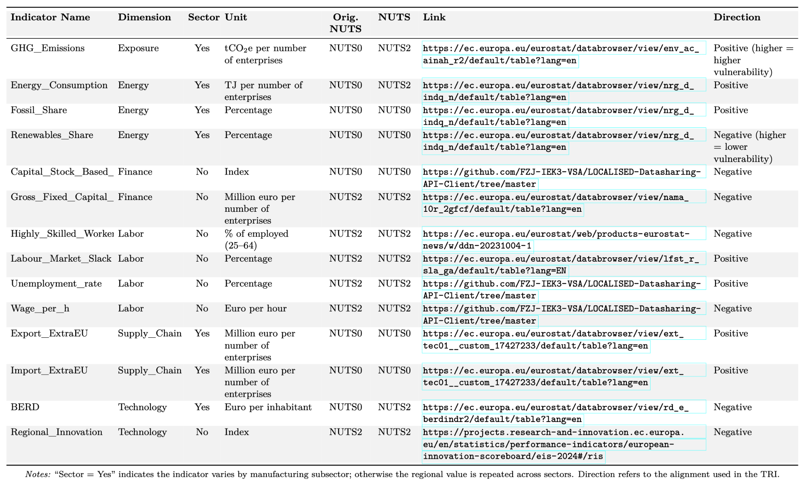
Table A2. Conceptual mapping of vulnerability indicators to mechanisms in the TRI. The table specifies why each metric raises or lowers transition difficulty: higher energy consumption and fossil share increase vulnerability, while a higher renewables share reduces it; labour slack and unemployment raise vulnerability, whereas higher skills and wages mitigate it; greater extra-EU trade heightens vulnerability via dependence on external markets and CBAM exposure; stronger BERD and regional innovation lower vulnerability by enabling technology adoption; higher capital productivity and gross fixed capital formation reduce vulnerability by easing retrofit and investment needs. This rationale guides the sign alignment used before normalization in the composite vulnerability index.
Table A2: Indicators by dimension
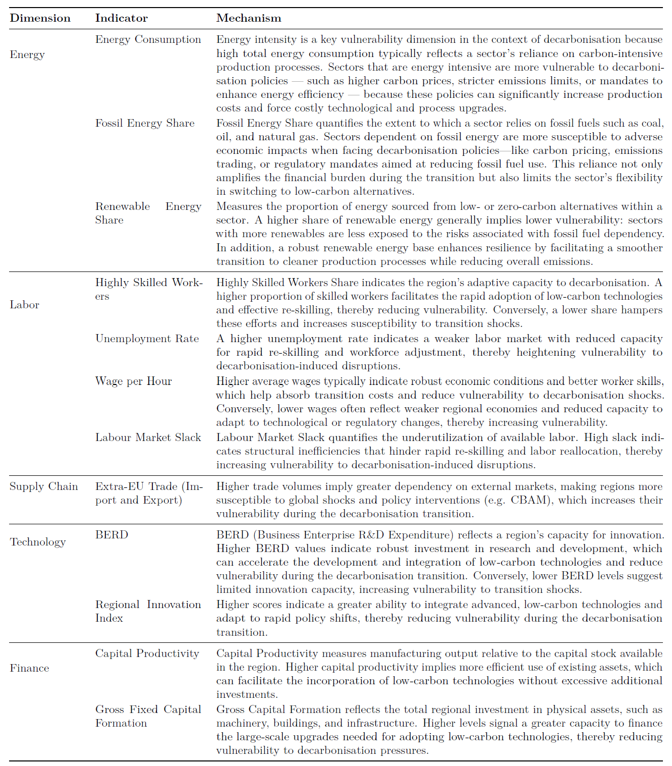

Table A3. Descriptive statistics at the region–sector level (NUTS-2 × manufacturing subsectors). All indicators are rescaled to 0.01,0.990.01, 0.990.01,0.99 and direction-aligned so that higher values denote greater transition difficulty, except GHG emissions, for which true zeros are preserved to reflect region–sector pairs with no recorded emissions (min = 0). The sample comprises 2,519 region–sector observations (2,475 for Regional Innovation). Indicators that do not vary at the sector level (e.g., regional values or sectoral averages) are repeated across sectors and thus remain constant within a region. Exposure proxies (GHG emissions, energy consumption) have low means (~0.13–0.16) and right-tailed distributions, indicating that a few high-emitting region–sectors drive exposure. Several vulnerability pillars (e.g., BERD, gross fixed capital formation) bunch near the upper bound with strong negative skew and high kurtosis, signalling widespread capacity shortfalls. Labour and trade variables sit mid-range, while energy-mix indicators suggest generally high fossil reliance and limited effective renewables—patterns consistent with TRI hot spots where concentrated exposure meets elevated vulnerability.
Table A3: Descriptive statistics of indicators (normalized values)
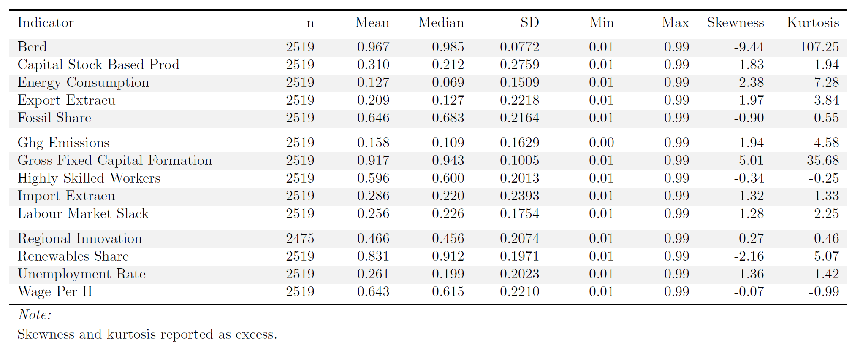

Table A4. Sector taxonomy used in the TRI. We aggregate NACE Rev. 2 manufacturing codes (C10–C33) into 10 subsector groups to harmonize data across sources and ensure sufficient region–sector coverage. The scheme preserves key energy-intensive categories (e.g., basic metals C24; non-metallic minerals C23; chemicals/petroleum C19–C20) alongside higher-tech segments (e.g., pharma/plastics C21–C22; electronics C26–C27). C25, C28, C29 and C30 are combined into one group. All TRI exposure and vulnerability metrics are computed at NUTS-2 for each of these groups.
Table A4: Subsector description
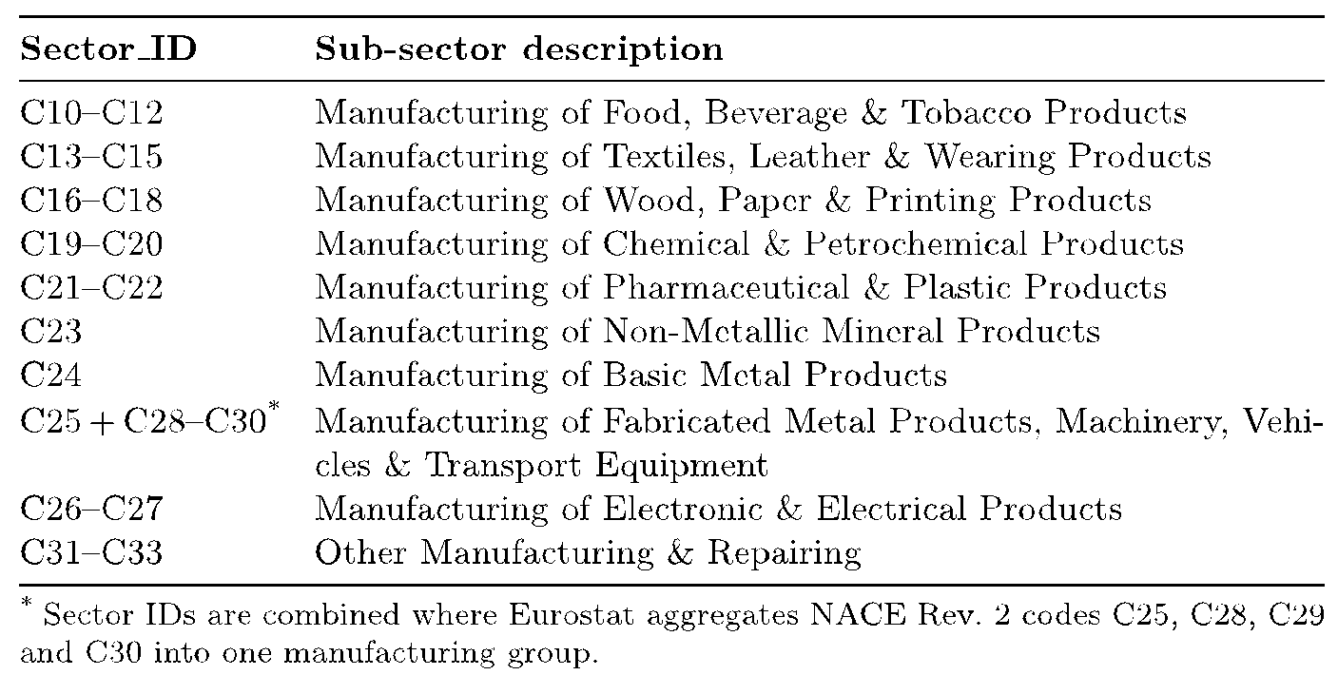

Figure A1. Distribution of normalised TRI scores (0–1) across NUTS-2 per manufacturing subsectors. The histogram is right-skewed: most region–sector pairs cluster around 0.25–0.45, with a long tail toward high values and only a small mass above ~0.75. The small spike at 1.00 reflects max-normalised cases that set the upper bound. The risk bands are quintiles.
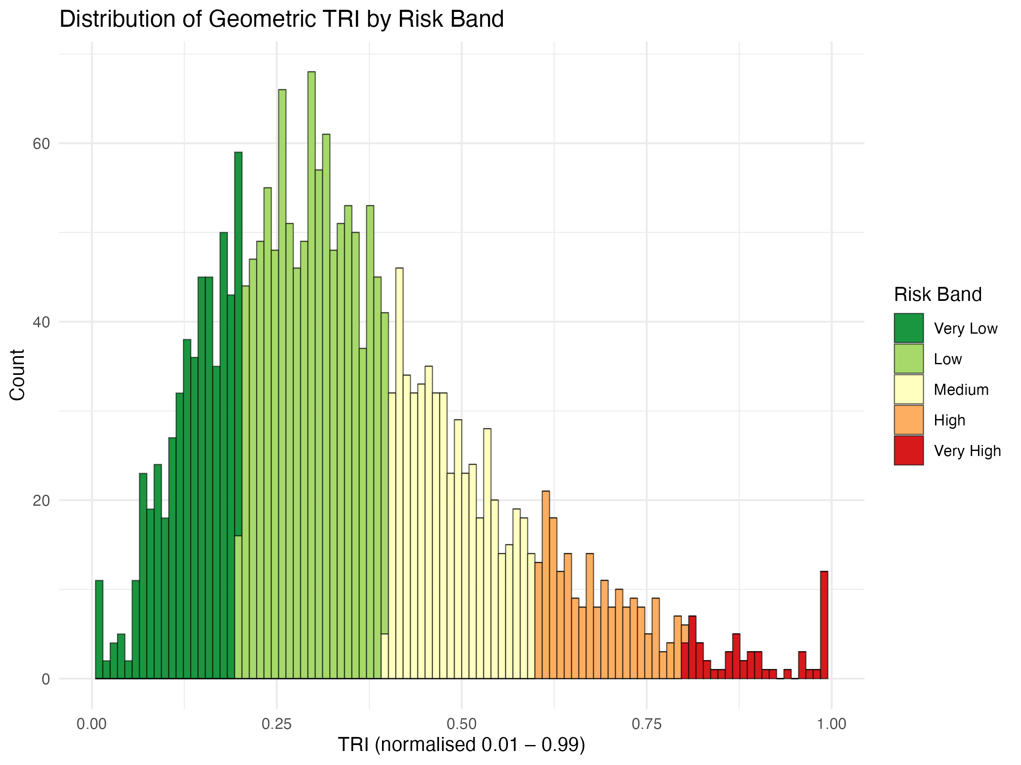
Figure A1: Distribution of the risk index by risk band

Figure A2 and A3. Exposure is the dominant driver of TRI in both sectors. Risk rises monotonically with Exposure and bands separate cleanly. Energy vulnerability is strongly positive. The gradient is steeper in Basic Metals. Technology is positive with more spread. Finance is positive but noisy. Labour shows little relation and sometimes a slight negative slope. Supply-chain is weak and discretized.
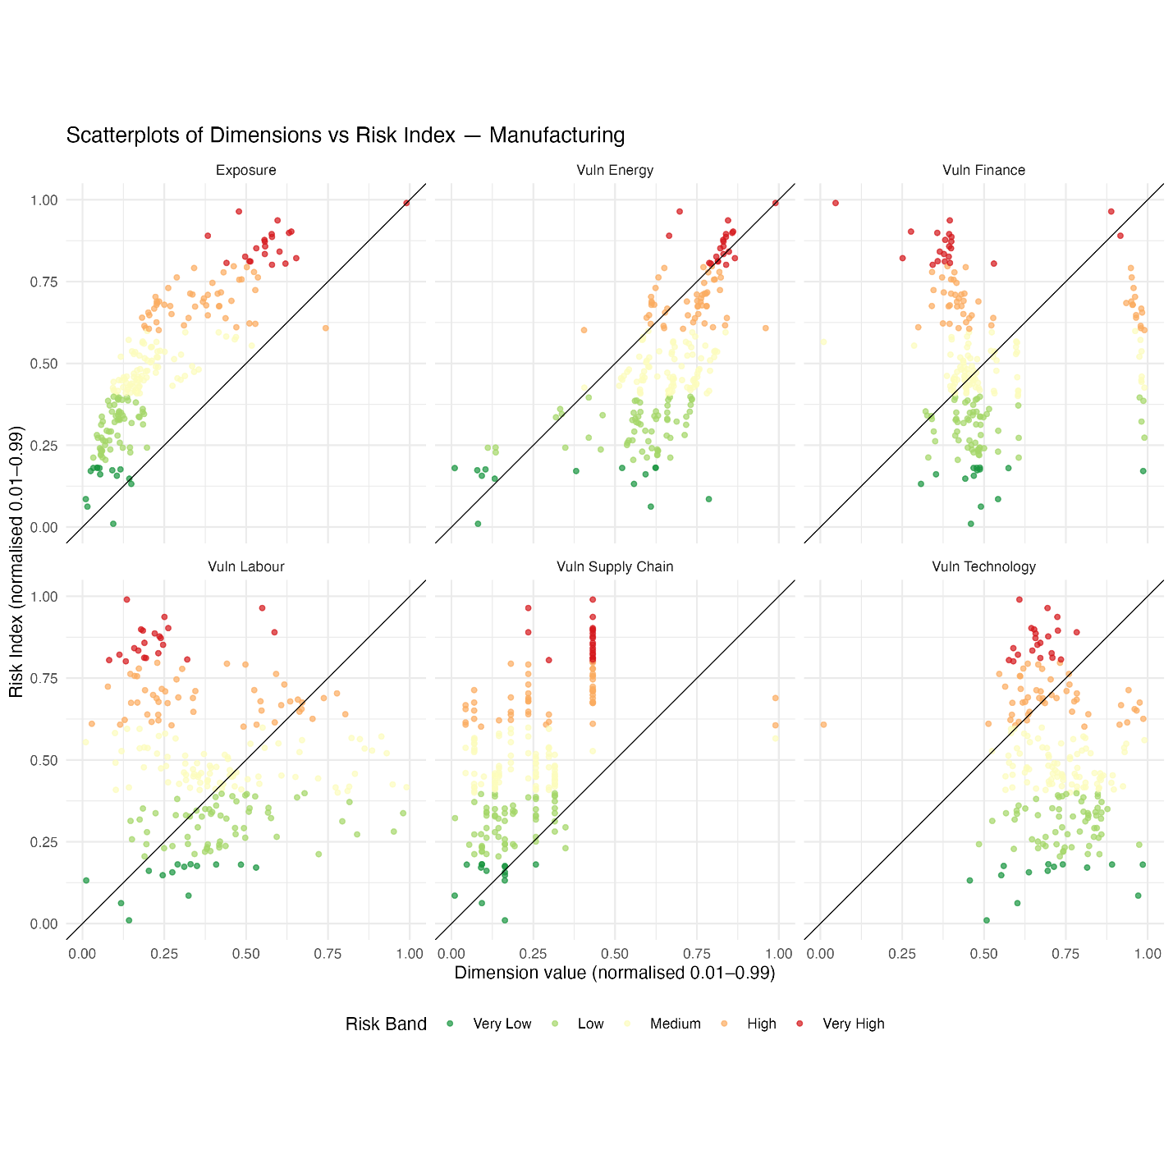
Figure A2: Scatterplot of exposure and vulnerability dimensions plotted against risk score for the total manufacturing sector
Manufacturing clusters at low exposure and low risk. Basic Metals shifts toward mid–high exposure and shows a thicker high-risk tail. High-risk points concentrate where Energy and Technology are high, even when Finance is only moderate. Bands separate well along Exposure and Energy, poorly for Labour and Supply-chain. Most points lie below the 1:1 line at low x and approach it at high x, consistent with risk requiring multiple high pillars. Removing outliers tightens the clouds and sharpens the monotonic patterns for Exposure, Energy, and Technology. Labour and Supply-chain change little, implying structural noise.
Implication: prioritize Exposure, Energy, and Technology for explanation and intervention, especially in Basic Metals. Treat Labour and Supply-chain as secondary and context specific. Consider interactions between Exposure and Energy or Technology in models.
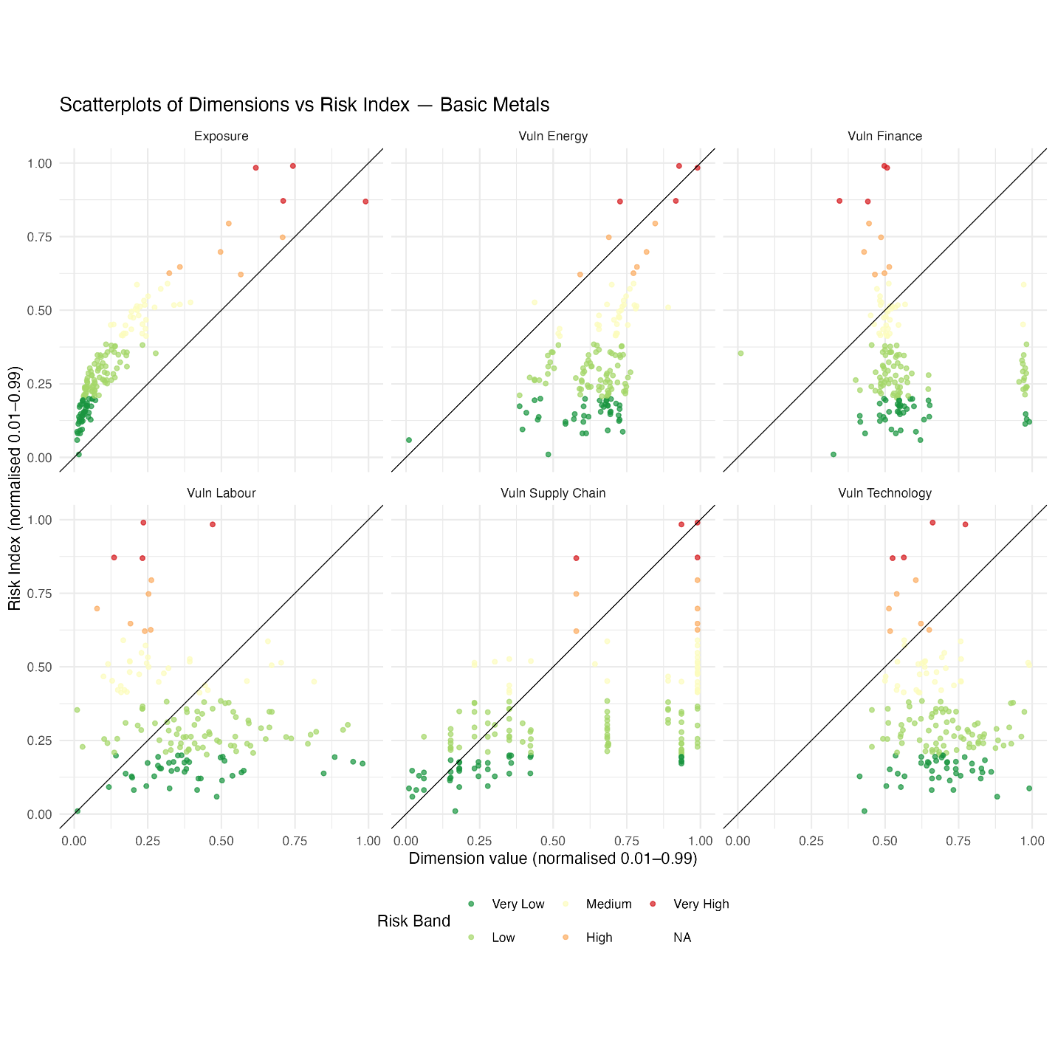
Figure A3: Scatterplot of exposure and vulnerability dimensions plotted against risk score for the basic metal sector

